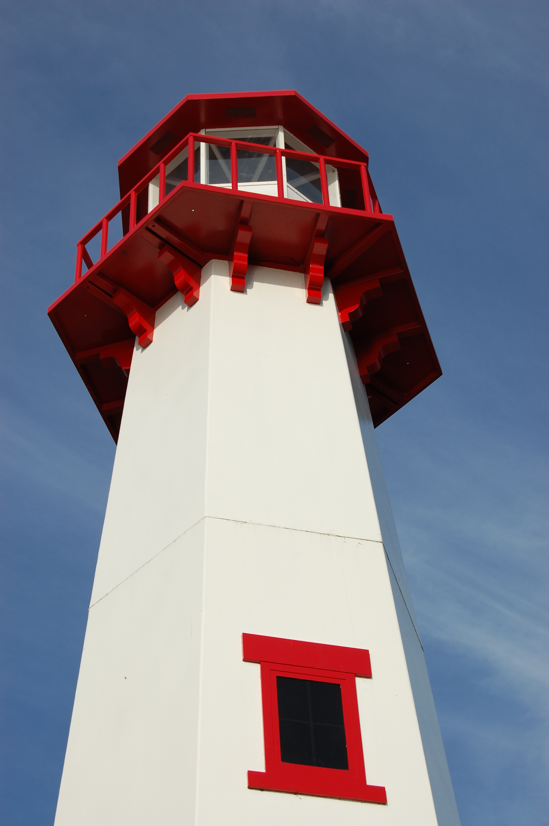
THE LIGHTHOUSE

Newsletter for November 2017

The night is nearly over; the day is almost here. So let us put aside the deeds of darkness and put on the armor of light. Romans 13:12

Message from Our Pastor

Dear Sisters and Brothers in Christ,

I love worship, but there is a part of worship that always brings a special joy to my heart. That’s when we prepare for communion with the Great Thanksgiving:
The Lord be with you.
And also with you.
Lift up your hearts.
We lift them to the Lord.
Let us give thanks to the Lord our God.
It is right to give our thanks and praise.
It is indeed right our duty and our joy, that we should at all times and in all places give thanks and praise to you, almighty and merciful God, through our Savior Jesus Christ; who on this day overcame death and the grave and by his glorious resurrection opened to us the way of everlasting life. And so, with all the choirs of angels, with the church on earth and the hosts of heaven. we praise your name and join their unending hymn:

There is something about joyfully giving thanks to God and then breaking of bread together that is very special. We see it throughout the bible from the Old Testament to the New Testament. It’s that coming together and giving thanks for all that we have been given that makes it special.

God has given us so many gifts, and it’s wonderful to share that sacred time together. As Christians we really do celebrate The Great Thanksgiving every week when we come to the Lord’s Table for communion, where all are welcome to taste and see that the Lord is good. It’s doesn’t matter if you’re a long-time member of the church family, or someone who is just passing through.

I have had numerous phone calls from out of town people asking if we are having communion on Sunday. In one of those phone calls the gentleman asked me if all are welcome. It brought joy to my heart to tell him “why yes all are welcome here”. And when he asked “Are you sure?” my smile got even bigger when I told him “yes I’m pretty sure” because I am the Pastor!

God welcomes all, without judgment, to the table. It is in that bread and wine where all of our sins are forgiven, through Christ’s precious body and blood. It is given so freely for us, even though we fall short, to the glory of God. For that I am truly grateful!

I want to wish you all a very blessed and Happy Thanksgiving!

Yours in Christ,
Pastor David

Newsletter

The November newsletter was not adopted. ☹
All Saint’s Day

November 1st is All Saint’s Day. This is a day in the church when we remember all the baptized who’ve gone before us. In the past year, we have buried the following saints:

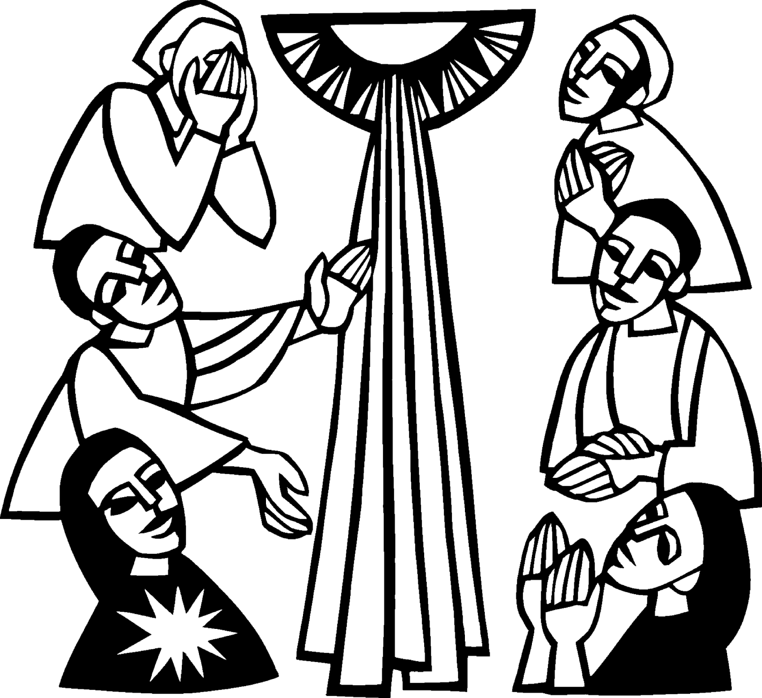
Judy Childs
Harold Klave
Gary Brolia
Barb Trainor-Hoyt
Charles Beeck
Kathryn Essary
Marilyn Yeager
William Alatalo
Virginia Nelson Hopper
Judy Schlehuber Bridges
LaTaunya Paquin

Noisy Offering

November noisy offering will go to the Mackinac County Children’s Toy Drive.

Calendar Note

Daylight Savings Time changes on November 5th. Turn your clocks back. Smoke detector batteries should be replaced at least once a year. People often change them when the clocks change.

Women’s Group

On November 5th, the Ladies of Zion will meet after church for lunch, fellowship and discussion.

Adult Bible Study

Bible Study at Trinity will be Tuesdays at 6 pm.

Prayer Time with Pastor

Join Pastor on Friday Mornings at 10 a.m. for a time of prayer in the sanctuary. If you are unable to make it and have a prayer request you would like pastor to pray for, leave a note on a folded piece of paper in the collection plate, or in the prayer basket in the family life center.

Confirmation

Confirmation will be on November 12th from 5 to 7 pm

Advent is Coming!

We will be decorating the church for Advent, following the service on Sunday, November 26th. Please help out if you can.

Prayer List

(If you would like someone added to the prayer list, email or call the church)

Mary Belonga, Dave & Lois Movalson, Barb Lehto, Bev Kammers, Joe Chalmers, Nadine Dandona, Patty Thibault, Karen Fowler, Delores Marshall, Bill & Sandy Tielbar, Walter & Jane Puccio, Linda & Mike Wilkins, Bill Anderson, Karen Kammers Sparks, Rick Brown, Eric Rose, Russell Winberg, Tom & Taffy Coffey, Charlie Doud, Richard Galor, Sarah Marolf, Eunice Therrian, Wes Pechta, Lou Hitts, Jack Dyer, Rick Weiss, Toni Leny, Judy Ryerse, Mandy Jones, Carol Watson, Bea Zak, Aiden, Rodney Novenske, John Lata, Jody Gustafson, Gaven Gustafson, Craig Therrian, Cindy Hendricks, Larry First, Billy Milford, Shirley Winberg, Larry Hopper, Ann & Bill Blaine, Carter Klein, Owen, Bernie, Molly, Mary Ellen Reavie, Carol Litzner, Holly Lester and the family and friends of Judy Schlehuber Bridges, LaTaunya Paquin & Joel Morabito


Long-Term Care

Cedar Ridge:
Cindy Hendricks
Bernard Crouch

Evergreen Living Center:
Nadine Dandona
Barb Lehto
Judy Ryerse

Baptismal Anniversaries

November 2 Joshua LaJoice
November 12 Misti Gamble
November 13 Tim Idalski
November 14 Adrian Coleman

November 14 Madison Coleman
November 17 Kristen Olsen
November 21 Duane Gamble
November 25 LaRoy Hill
November 27 Mike Wilkins
November 27 Mandy Bowlby

Birthdays in November

November 3 Tim Idalski
4 Ernie Vallier
4 Linda Wilkins
7 Rita LaVake
11 Kathy Marshall
11 Samantha Wyers
12 Shirley Winberg
15 Nancy Hardy
15 Alicia LaLonde
17 Faith Gaubault
17 Wyatt Huhn
17 Kyra Spencer
18 Lori Wilkins
19 Connie Olsen
19 Justin Stenson
22 Lisa Gamble
23 Shirley Campbell
25 Dawn Akers
26 Misti Gamble
29 Jessie Rogers

Contact Information

Pastor David Tielbar may be reached at 906-984-2051 or at david.tielbar6@gmail.com. In an emergency, you can reach the Pastor’s cell phone at (563) 880-4512

Church telephone: 906-643-7870 - Answering machine
The secretary will usually be in the office on Tuesday and Thursday mornings from 9 – 12

To email the church is: ziontrinity950@yahoo.com

The website is at http://zionstignace.com/home.html
- Find us on facebook at www.facebook.com/zionstignace

Zion Evangelical Lutheran Church and Trinity Lutheran Church are congregations of the Northern Great Lakes Synod and the Evangelical Lutheran Church in America.

Trinity’s Sunday Service is at 9 a.m.
Zion’s Sunday Service is at 11 a.m.

Trinity Worship Families

Nov 5 Kennedy Family
Nov 12 Movalson Family
Nov 19 Rose Family
Nov 26 Baron Family

Zion Funeral Committee October - January

Team Leader: Lorraine Graham (643-8419)
Co-leader: Lana Lennington (643-6576)

Servants for Zion

Ushers & Greeters

Nov 5 Sam LaVake Family
Nov 12 Confirmation Youth
Nov 19 Amy Dodds Family
Nov 26 Mark & Carol Elmblad

Lectors

Nov 5 Dawn Akers
Nov 12 Rita LaVake
Nov 19 Lorraine Graham
Nov 26 Sandy Feleppa

Communion Assistants

Nov 5 Dena Barker
Nov 12 Mary Christiansen
Nov 19 Karen Schlehuber
Nov 26 Steve Christiansen

Acolytes

Nov 5 Brendan Donovan
Nov 12 Josh Feleppa
Nov 19 Brendan Donovan
Nov 26 Josh Feleppa

Altar: Karen Schlehuber
Money Counters: Lana Lennington & Dena Barker

The Usher duties are:
- Arrive 30 minutes before church
- Pass out bulletins and welcome guests
- Help with the offering and communion
- Record attendance

Council Meetings

Trinity Council – November 21, 6 pm
Zion Council – November 15, 6:30 pm

Zion’s Council Members
President: Steve Christiansen 298-1051
Vice-President Karen Schlehuber 643-0311
Co-Treasurers: Dawn Akers 643-7552
Co-Treasurers: Lana Lennington 643-6576
Secretary: Lorraine Graham 643-8419
Mary Christiansen 235-6123
Robert Marshall 643-8936
Dena Barker 430-1460
Paul Shepard 984-2069

Trinity’s Council Members
President: Jerri Rose 292-5570
Vice-President Sharon Chalmers 292-5440
Secretary: Tracy Movalson 292-5581
Treasurer: Pega Kennedy 292-5633
Co-Treasurer: Jim Rose 292-5570
Financial Secretary: Tom Gustafson 292-5460
WELCA: Pega Kennedy 292-5633
John Kennedy 292-5633
Lois Movalson 292-5581

Trinity Lutheran Council Minutes

October 18, 2017

The meeting was opened at 6:15 p.m.

Those present were Jim and Jerri Rose, John and Pega Kennedy, Tom Gustafson, Sharon Chalmers and Pastor David

Opening: Devotion/Prayer, Pastor opened our meeting with a devotion from "Portals of Prayer" and from 1 Corinthians 2:10

Pastor's Report - We are getting close to Referendum Sunday. The Installation of our new Bishop is on Saturday October 21. Pastor is attending and invited anyone of us who wants to boarder up to Marquette.

Secretary's Report - Tracey Movalson reported last month's minutes by speaker phone. Minutes were accepted as read

Treasurer's Report - Passed

Financial Secretary Report - Passed

Old Business

Donations were made to the Loryce M. Dyer Hospice ($500.00) and to the Lutheran Disaster Relief Response ($1000.00).

New Business

We set the date for our community Christmas dinner for12/2/17.

The meeting was adjourned at 6:35 with the Lord's Prayer.

Respectfully submitted,
Sharon Chalmers for Tracey Movalson, Secretary

Zion Lutheran Council Meeting
October 25, 2017

Council Members Present: Stevan, Mary, Karen, Lorraine, Dawn and Pastor David

Steve called the meeting to order at 6:45 pm.

Pastor Dave opened with devotions “It’s unbelievable”.

1. Pastor's Report:
- Pastor is meeting with Pastor Susie to plan for the Community Thanksgiving Service on November 19th.
- We have our students registered to go to the Youth Gathering in Houston this summer.
- With the large amount of rain, we have discovered water issues in the church as well as the parsonage. It has been recommended that we contact a contractor immediately. Insurance may help with the cost.
- The Endowment Committee met after church and discussed what they would use the money for. Pastor suggested the Food Truck and the Hope Chest heating fund. It was also suggested that we do something with the elevator. (The council suggested having the Endowment Committee give toward the water issues)
- It was suggested to the pastor to perhaps get a mike for people speaking in church meetings so everyone could hear.

2. Treasurer's Report:
The Treasurer’s Report was read and approved.

3. Secretary's Report:
Secretary's Report was read and approved

4. Old Business:
- Everything’s ready for the pasty sale. We are, for the most part, only making enough for the orders as we had a lot left over last year.

5. New Business:
- Steve showed a letter from the Bishop asking for our pledge. Dawn says to wait until after the budget meeting in January to fill it out.
- Steve showed us the Endowment Fund Account paperwork from which we use the interest for Endowments. Dawn says we still need the information from the bank account.
- There was a discussion on shortening the bulletins but it was decided to leave it as is.
- We made changes to the list of Noisy Offering recipients.
- We discussed possible replacements for Karen, Lorraine and Paul on the Council.
- The November calendar was discussed. Council will be on the 15th and there will be no Bible Study. The Craft Show will be in December.
- Karen presented her final report on the finances for the women’s group. She will be leaving for Arizona in December and someone will need to take over from her at our next meeting. (November 5th)

Meeting was adjourned with the Lord’s Prayer at 7:45 pm.

Respectfully Submitted, Lorraine Graham
Treasurer's Report for Zion
January 1, 2017 through October 25, 2017
Income:
 | Amazon Smile Foundation | $ 52.20
 | Building | $ 95.00
 | Church Use Income | $ 990.00
 | General | $ 46,743.11
 | Fund Raising - Soup Luncheon | $ 1,518.90
 | Thrivent Financial Income | $ 446.00
 | Trinity Share | $ 11,069.89
 | TOTAL |  | $ 60,915.10
Expenses:
 | Administration | $ 3,137.24
 | Benevolence | $ 1,201.64
 | Church Maintenance | $ 12,056.89
 | Education | $ 546.35
 | Parsonage Maintenance | $ 2,913.87
 | Pastoral | $ 39,079.47
 | Worship | $ 3,287.30
 | --To Building Fund | $ -
 |  |  | $ 62,222.76
 |  |  | -1307.66
*****************************************************
Thrivent Financial Investment Fund |  |  | 320.83
General fund balance: |  |  | -679.09
Kitchen/Building Fund balance |  |  | 256.85
General fund owes building fund: |  |  | $ 95.00
General fund owes Mission Endowment fund: |  |  | $ 7,995.00
Annual Turkey Dinner

The Annual Turkey Dinner & Craft Sale sponsored by the United Methodist Church will be on Thursday, November 2nd, 5 – 6:30 pm at the LaSalle High School Cafeteria.

Vote!!!

November 7th is Election Day. Get out and vote!

Bake Sale

The Mackinac Animal Aid Association
will be holding a bake sale at Family Fare
on November 11th starting at 9:30 a.m.

Community Thanksgiving

The Community Thanksgiving Service will be at the United Methodist Church on Sunday, November 19th at 7 pm. All are welcome to join us in giving thanks for all of our blessings.

Craft & Vender Show

We will be having a Craft & Vender Show on the first Sunday of December. Anyone wanting to have a display table should contact Cathie Tielbar and Sandy Feleppa

